**Ch 31: Fungi**

1. Identify characteristics that distinguish fungi from other eukaryotes.
2. Compare mitosis in fungi and animals.
3. Explain why fungi are useful for bioremediation.
4. Explain characteristics that led microsporidians to be classified as protists.
5. Describe evidence for placing microsporidians with fungi.
6. Distinguish between blastocladiomycetes and microsporidians.
7. Explain the meaning of “chytrid”.
8. Discuss possible uses of neocallimastigomycetes.
9. Describe the defining feature of the zygomycetes.
10. Explain the advantage of zygospore formation.
11. Explain why Glomeromycota is now considered separate from Zygomycota.
12. Explain which cells in the life cycle of basidiomycete are diploid.
13. Distinguish between primary and secondary mycelium in basidiomycetes.
14. Compare the ascomycetes and the basidiomycetes.
15. List the ways ascomycetes affect humans.
16. Identify a trait that contributes to the value of fungi in symbiotic relationships.
17. Describe the living components of a lichen.

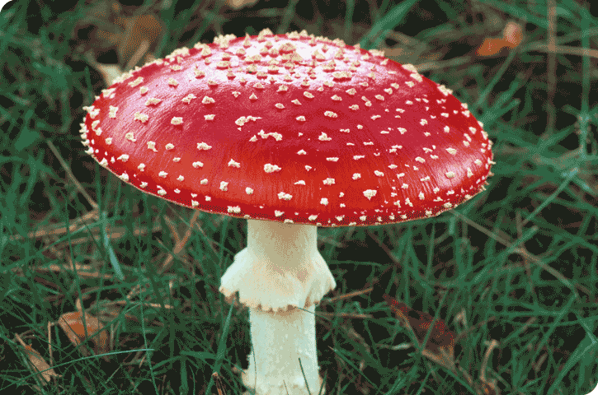

1. List examples of fungal associations with different organisms.
2. Review the pathogenic effects of fungi and the targets they affect.
3. Explain why treating fungal disease in animals is particularly difficult.