**Ch 28: Prokaryotes**

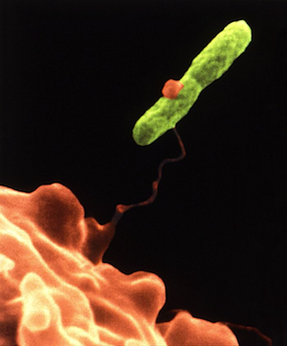

1. Explain the evidence for the earliest cells.
2. Describe possible pathways of carbon fixation by early life forms.
3. Differentiate among archaea, bacteria, and eukarya.
4. Describe the basic features of bacteria and archaea.
5. Explain classification methods for prokaryotes.
6. Describe the general features common to all prokaryotic cells.
7. Explain the differences between gram-positive and gram-negative bacterial cells.
8. Describe the features that distinguish different kinds of prokaryotic cells.
9. Contrast the mechanisms of DNA exchange in prokaryotes.
10. Explain genetic mapping in E. coli.
11. Describe how genetics explains the spread of antibiotic resistance.
12. Describe the different ways that prokaryotes acquire energy and carbon.
13. Explain how bacterial proteins can cause disease in humans.
14. Describe common human bacterial pathogens.
15. Explain how bacteria can cause ulcers.
16. Identify sexually transmitted diseases caused by bacteria.
17. Recognize the role of prokaryotes in the global cycling of elements.
18. Describe examples of bacterial/eukaryote symbiosis.
19. Explain how bacteria can be used for bioremediation.